**Client-Side App Rubric** <https://github.com/denisecase/pbl-lifeline-links>

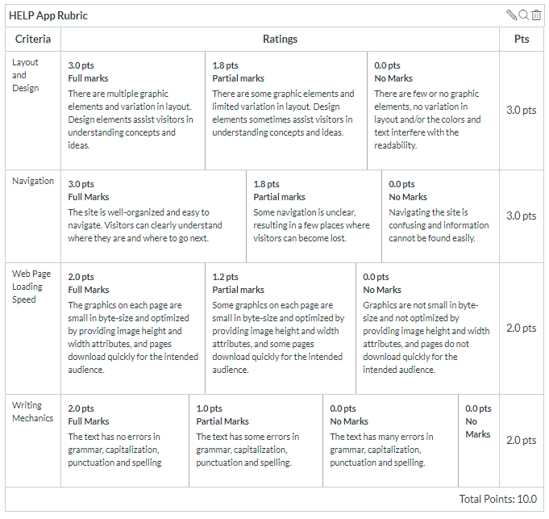

**Team reviewed:** Group 04 - 04

**Link to the web site:** https://github.com/Sravani537520/Help_app/

**Layout and Design**

Score: 3.0

Comments: Group utilized various images and graphics, such as tables, to help enhance information on website. Layout flowed well and they used variants for each page. The only issue is “login” button on the right side of the navigation is against the right edge of the screen.

**Navigation**

Score: 2.8

Comments: Navigation works as it should and scrolls to where the appropriate information is located. Also links to emergency contact work as well. “HELP” logo in top left should link to Home/Top of the page.

**Loading Speed:**

Score: 2.0

Comments: Page loads instantly, main image is loaded within a second of entering the site. The slideshow images have a slight delay before they load, but load relatively quickly.

**Writing Mechanics:**

Score: 1.9

Comments: Overall the site contains complete sentences with proper grammar and spelling. On the Home page there are 2 missing commas. “As volunteers we strive to provide…” should have a comma after “volunteers”. “…technology at reasonable cost thereby allowing…” should have a comma after “cost”.

**General remarks:**

Over all, the site looks and functions well. There were no large issues that made the site difficult to read or navigate through. The layout works well and flows easily from page to page.

**Review performed by:**

Web Dev II Group 6

Tosh Newton, Brendan Weybrew, Leslie Mills

**Date and time performed:**

Thursday, December 5, 2019 1:00 p.m.